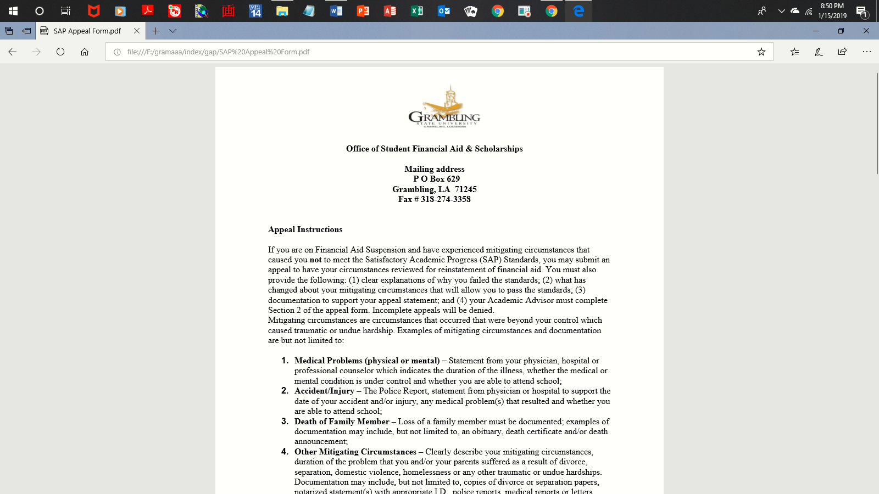

**Office of Student Financial Aid & Scholarships**

**Mailing address**

**P O Box 629**

**Grambling, LA 71245**

**Fax # 318-274-3358**

**Appeal Instructions**

If you are on Financial Aid Suspension and have experienced mitigating circumstances that caused you not to meet the Satisfactory Academic Progress (SAP) Standards, you may submit an appeal to have your circumstances reviewed for reinstatement of financial aid. You must also provide the following: (1) clear explanations of why you failed the standards; (2) what has changed about your mitigating circumstances that will allow you to pass the standards; (3) documentation to support your appeal statement; and (4) your Academic Advisor must complete Section 2 of the appeal form. Incomplete appeals will be denied.

Mitigating circumstances are circumstances that occurred that were beyond your control which caused traumatic or undue hardship. Examples of mitigating circumstances and documentation are but not limited to:

1. **Medical Problems (physical or mental)** – Statement from your physician, hospital or professional counselor which indicates the duration of the illness, whether the medical or mental condition is under control and whether you are able to attend school;
2. **Accident/Injury** – The Police Report, statement from physician or hospital to support the date of your accident and/or injury, any medical problem(s) that resulted and whether you are able to attend school;
3. **Death of Family Member** – Loss of a family member must be documented; examples of documentation may include, but not limited to, an obituary, death certificate and/or death announcement;
4. **Other Mitigating Circumstances** – Clearly describe your mitigating circumstances, duration of the problem that you and/or your parents suffered as a result of divorce, separation, domestic violence, homelessness or any other traumatic or undue hardships. Documentation may include, but not limited to, copies of divorce or separation papers, notarized statement(s) with appropriate I.D., police reports, medical reports or letters from professional counselors and documentation indicating circumstances have improved or been resolved.

**Appeal Decision**

Your appeal decision (approved or denied) will be indicated via banner web; processing time is normally seven to ten business days except during peak seasons. The appeal decision will be based on the strength of your appeal statement, documentation received and your academic record. Filing an appeal does not guarantee Financial Aid reinstatement. You are responsible for any charges incurred during period/s of ineligibility.

**Grambling State University**

**Office of Student Financial Aid & Scholarships**

**Satisfactory Academic Progress (SAP) Appeal**

**2017-2018**

**SECTION 1 TO BE COMPLETED BY STUDENT**

In order for your appeal to be processed, please PRINT neatly in blue or black ink

|  |  |  |  |  |  |
| --- | --- | --- | --- | --- | --- |
| Student Name (last, first, middle initial): | |  | G#: |  | Local Telephone Number: |
|  | |  |  |  |  |
|  | | | | | |
| Mailing Address: |  | | | | |
|  | | | | | |

**Step 1:** Clearly explain the Mitigating Circumstance(s) that caused you to fail the standard(s).



**Step 2:** Explain what has changed about those mitigating circumstances that will now allow you to pass the standards.



**Step 3:** Student Certification and Signatures

I certify that the information I have provided is true and complete to the best of my knowledge. By completing and submitting this form you certify that: (1) I have reviewed the SAP policy and understand you have fallen below the acceptable SAP standards required for financial aid; (2) I understand that the submission of an appeal does not guarantee approval and that your financial aid may not be reinstated for this semester and future semesters; (3) I and an academic official agree that the courses you are taking during this enrollment period are acceptable toward meeting your degree requirements and the SAP standards;

|  |  |  |  |
| --- | --- | --- | --- |
| **Student Signature:** |  | **Date:** |  |

|  |  |  |  |
| --- | --- | --- | --- |
| **Name** |  | **G#** |  |

**SECTION 2 TO BE COMPLETED BY ACADEMIC ADVISOR**

**(An Incomplete Form Will Be Denied)**

1. **Academic Plan**

The student listed above is currently on financial aid suspension and is filing an appeal with the Financial Aid Office regarding his or her Satisfactory Academic Progress. An Academic Plan must be developed, signed and maintained by their academic advisor including the coursework to be attempted during the appeal semester. If the appeal is approved, the student will be expected to meet all the conditions of their Academic Plan; otherwise, the student will be placed back on financial aid suspension.

|  |  |  |
| --- | --- | --- |
| **Major** |  | |
|  |
| **Anticipated Graduation Date** | |  |
|  |
| **Total Hours Required for Degree** | | | |  |
| **Total Hours Attempted (Including Transfer Hours)** | | | |  |
| **Total Hours Earned Toward Degree (Including Transfer Hours)** | | | |  |
| **Total Hours Needed To Complete Degree Requirements** | | | |  |

**Recommend Courses for Current Semester:**

|  |  |
| --- | --- |
| To establish and maintain Satisfactory Academic Progress, I recommend that |  |
| take the courses listed below: | *student name* |

|  |  |  |
| --- | --- | --- |
| **Course No.** | **Course Title** | **Hours** |
|  |  |  |
|  |  |  |
|  |  |  |
|  |  |  |
|  |  |  |
| **TOTAL** | |  |

**Academic Advisor Certification and Signatures**

Your signature indicates that you have discussed with the student their current status, expected graduation date and that the courses listed above are acceptable for the semester of appeal.

|  |
| --- |
| **Academic Advisor’s Name (Print)** |
|  |
|  |
| **Academic Advisor’s Signature** |