PUT YOURSELF
IN POSITION
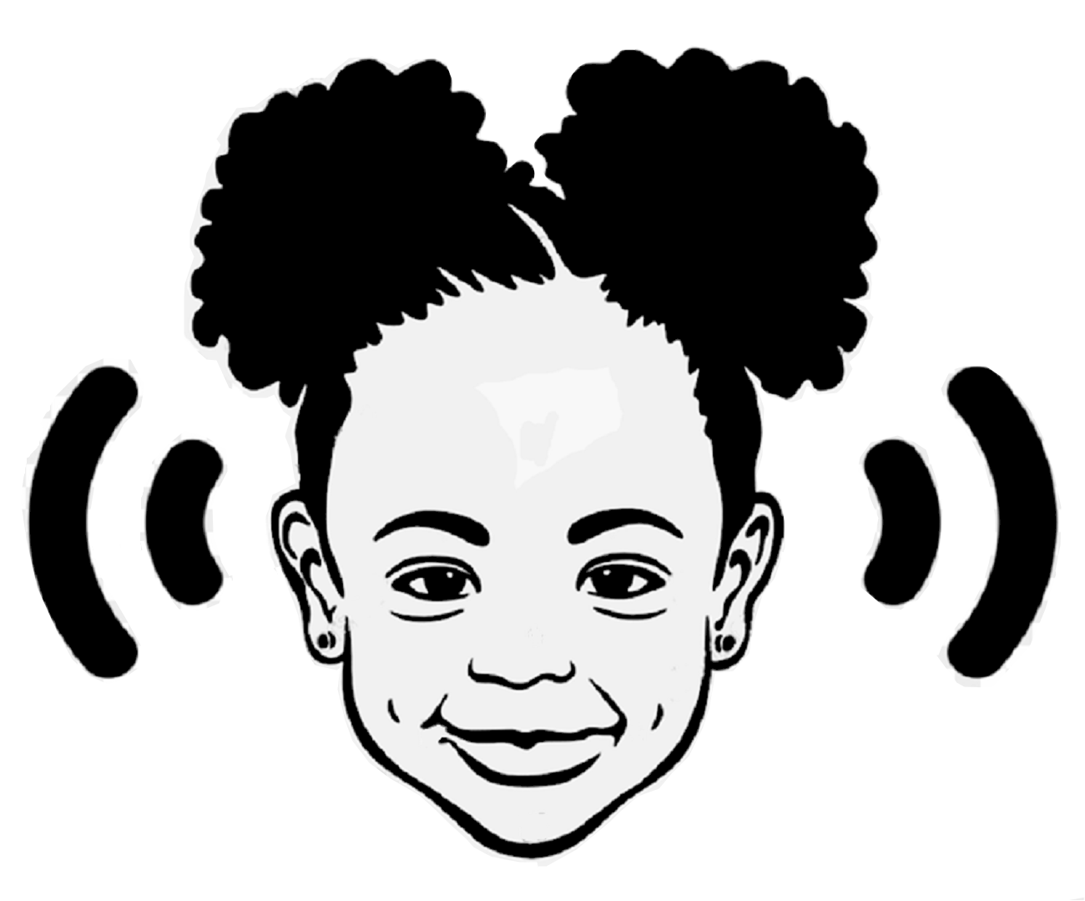
TO LISTEN!
PUT YOURSELF
IN POSITION
TO LISTEN!
